Sunday | Monday | Tuesday | Wednesday | Thursday | Friday | Saturday
 | 1  Morning Exercise/Daily News  Walk**  Afternoon Weekly Bingo Numbers  Hallway Crafts: Painting  Evening Activity Trolley | 2  Morning Exercise/Daily News  Walk**  Afternoon Weekly Bingo Numbers  Happy Hour Room Service  Traveling Trivia and Prizes | 3  Morning Exercise/Daily News  Walk**  Afternoon Weekly Bingo Numbers  Hallway Lemonade Stand  Evening Crossword Puzzles | 4  Morning Exercise/Daily News  Walk**  Afternoon Weekly Bingo Numbers  Popcorn and Drinks  Hallway Music Sing-along  Evening Adult Coloring Packets | 5  Morning Hallway Prayer  Walk**  Afternoon Weekly Bingo Numbers  Hallway Game Time  Evening Activity Trolley | 6  Morning Exercise/Daily News  Walk**  Afternoon Puzzles  Evening Adult Coloring
7  Morning Exercise/Daily News  Walk**  Afternoon Puzzles  Evening Adult Coloring | 8  Morning Exercise/Daily News  Walk**  Afternoon Weekly Bingo Numbers  Resident Council Survey  Hallway Crafts: Father’s Day Crafts  Evening Activity Trolley | 9  Morning Exercise/Daily News  Walk**  Afternoon Weekly Bingo Numbers  Happy Hour Room Service  Traveling Trivia and Prizes | 10  Morning Exercise/Daily News  Walk**  Afternoon Weekly Bingo Numbers  Summer Fruit Cart  Evening Crossword Puzzles | 11  Morning Exercise/Daily News  Walk**  Afternoon Weekly Bingo Numbers  Popcorn and Drinks  Hallway Music Sing-along  Evening Adult Coloring Packets | 12  Morning Hallway Prayer  Walk**  Afternoon Weekly Bingo Numbers  Hallway Game Time  Evening Activity Trolley | 13  Morning Exercise/Daily News  Walk**  Afternoon Puzzles  Evening Adult Coloring
14  Morning Exercise/Daily News  Walk**  Afternoon Puzzles  Evening Adult Coloring | 15  Morning Exercise/Daily News  Walk**  Afternoon Weekly Bingo Numbers  Hallway Crafts: Jewlery  Evening Activity Trolley | 16  Morning Exercise/Daily News  Walk**  Afternoon Weekly Bingo Numbers  Happy Hour Room Service  Traveling Trivia and Prizes | 17  Morning Exercise/Daily News  Walk**  Afternoon Weekly Bingo Numbers  Hallway Lemonade Stand  Evening Crossword Puzzles | 18  Morning Exercise/Daily News  Walk**  Afternoon Weekly Bingo Numbers  Popcorn and Drinks  Hallway Music Sing-along  Evening Adult Coloring Packets | 19  Morning Hallway Prayer  Walk**  Afternoon Weekly Bingo Numbers  Father’s day Hallway cart | 20  Morning Exercise/Daily News  Walk**  Afternoon Puzzles  Evening Adult Coloring
Father’s Day 21  Morning Exercise/Daily News  Walk**  Afternoon Puzzles  Evening Adult Coloring | 22  Morning Exercise/Daily News  Walk**  Afternoon Weekly Bingo Numbers  Hallway Crafts: Paper lanterns  Evening Activity Trolley | 23  Morning Exercise/Daily News  Walk**  Afternoon Weekly Bingo Numbers  Happy Hour Room Service  Traveling Trivia and Prizes | 24  Morning Exercise/Daily News  Walk**  Afternoon Weekly Bingo Numbers  Summer Fruit Cart  Evening Crossword Puzzles | 25  Morning Exercise/Daily News  Walk**  Afternoon Weekly Bingo Numbers  Popcorn and Drinks  Hallway Music Sing-along  Evening Adult Coloring Packets | 26  Morning Hallway Prayer  Walk**  Afternoon Weekly Bingo Numbers  Hallway Game Time  Evening Activity Trolley | 27  Morning Exercise/Daily News  Walk**  Afternoon Puzzles  Evening Adult Coloring
28  Morning Exercise/Daily News  Walk**  Afternoon Puzzles  Evening Adult Coloring | 29  Morning Exercise/Daily News  Walk**  Afternoon Weekly Bingo Numbers  Hallway Crafts: 4th of July Decorations  Evening Activity Trolley | 30  Morning Exercise/Daily News  Walk**  Afternoon Weekly Bingo Numbers  Happy Hour Room Service  Traveling Trivia and Prizes | 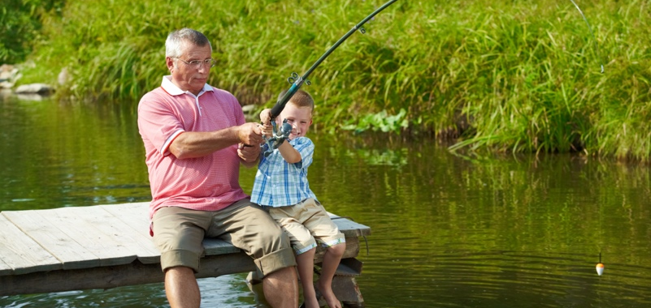  Celebrating WI Lakes & Landmarks  Happy Birthday  Muriel L. – 6/21  Norma D. – 6/23  Gwendolyn S. – 6/26  Name Initial. – 9/#  Name Initial. – 9/#  Name Initial. – 9/#
June
Heritage Monona
Enhanced First Floor Life Enrichment Calendar
NOTICE
Due to CDC recommendations, all activities are subject to change.

Musical Performance Happy Hour Spiritual Service

*All activities are subject to change when necessary
Residents’ families are invited to participate in community events. **Resident Led Activity

